Implementation Plan

Tasks: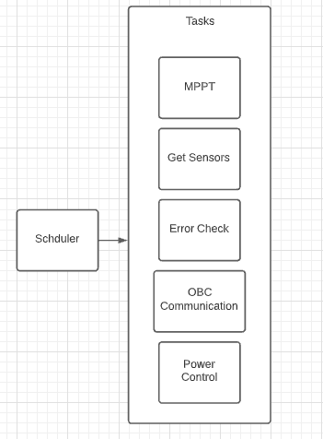

1. MPPT:

It’s responsible of stepping down the solar panels Voltages to a fixed voltage to charge the batteries by varying the pwm values to maintain the charging voltage at a stable value.

1. Get Sensors

Gets all sensors data (temp,voltage current,.. etc)

1. Error Check:

It generally checks for safety limits of the sensed quantities, checks for error status of the previous operations whether it’s done successfully or not.

1. OBC Com:

send error check report to obc & gets power control packet

1. Power Control:

Opens/Closes the power on the subsystems based on control packet recieved from OBC

Power Module :

Initialization:

eps_power_module_init

EPS_PowerModule_init_ALL

HAL_ADC_Init

HAL_DMA_Init

TIM3_Init

Tasks:

1. MPPT:

Functions:

1. EPS_PowerModule_mppt_update_pwm

2. EPS_PowerModule_mppt_apply_pwm

1. Power State:

EPS_update_power_module_state

Setters/Getters:

Getters:

module_X: pointer to the power module instance to set.

starting_pwm_dutycycle: initial duty cycle at which the power module will start the mppt !0 is not a good start.

htim: pointer to timer peripheral handle for pwm generation.

timer_channel: timer peripheral channel used for this pwm module.

hadc_power_module: pointer to adc peripheral handle that holds the current/voltage measurements.

ADC_channel_current: pointer to adc channel with the current measurement.

ADC_channel_voltage: pointer to adc channel with the voltage measurement.

module_top: pointer to top solar panel side power module.

module_bottom: pointer to bottom solar panel side power module.

module_left: pointer to left solar panel side power module.

module_right: pointer to right solar panel side power module

voltage_avg:

current_avg:

Setters:

Error status for handling and debugging.

duty_cycle

step_size

power_now_avg

TC_74:

Initialization:

1.GPIO_Init

GPIO_TC74_POWER_Pin

GPIO_HEATERS_Pin

2.I2C2_Init

Setters/Getters:

Getters:

h_i2c: pointer to the i2c bus peripheral handle that the temperature sensor ics are connected.

device_i2c_address: i2c adress of the sensor to request measurement.

receive_word: pointer to the word where the measurement register will be returned.

Setters:

TC_74_STATUS.

OBC Com

Initialization:

1.USART1_UART_Init